Fruit Solar System

To create the Fruit Solar System, you will need:
- 1 large watermelon
- 1 large grapefruit
- 1 apple
- 1 lime
- 1 blueberry
- 2 cherry tomatoes
- 1 peppercorn

Children should be encouraged to guess which fruit represents which planet and try to put them in order from the sun out. The sun is not on the fruit solar system, because on this scale we would need over 1 million cherry tomatoes to represent the Sun!!

This can be used in conjunction with the toilet-roll solar system (scale below diagram). See the BBC star-gazing live leaflet for details of this and other activities.

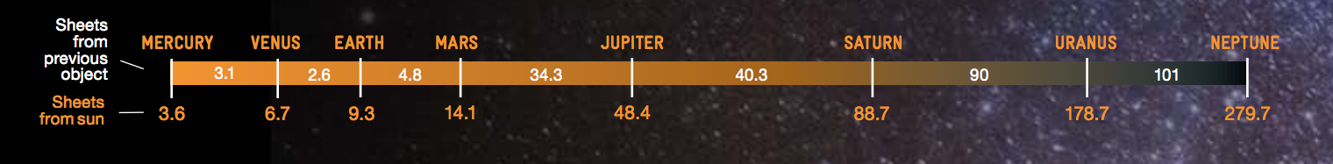
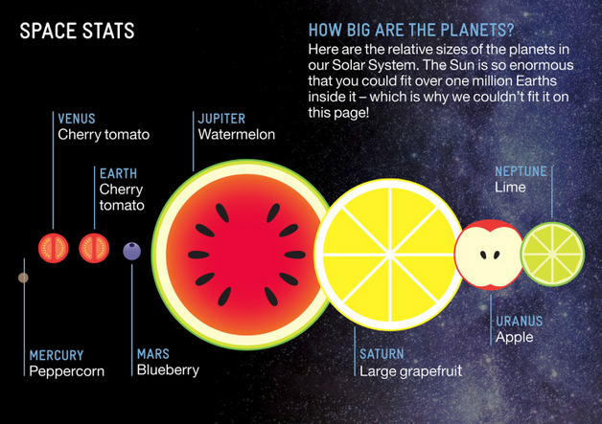
http://downloads.bbc.co.uk/tv/stargazinglive/sgl_eventpack_with_links2013.pdf

