Solar System using Play-doh
https://solarsystem.nasa.gov/educ/play_doh_planets
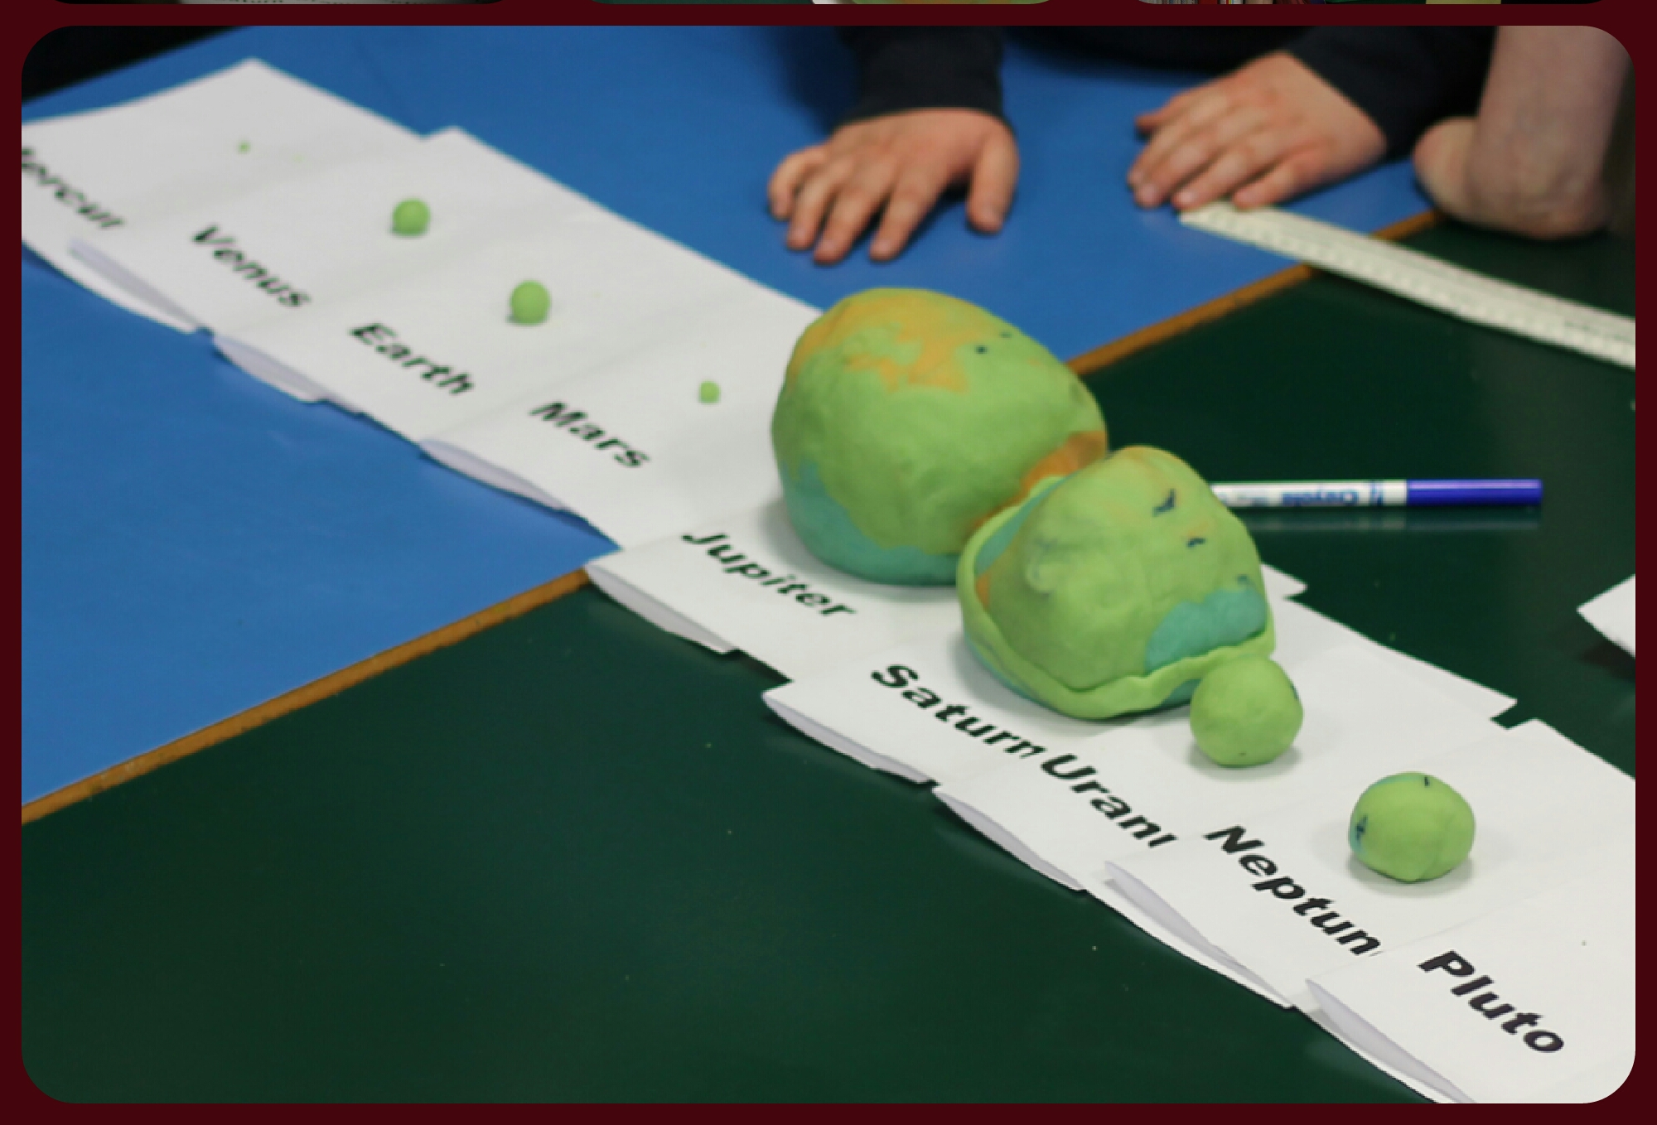
- Start with 30cm log of play-doh
- Cut into ten equal sections
- 6 sections make JUPITER
- 3 sections make part of SATURN
- Roll last section and divide into 10
- Add 5 sections to SATURN
- 2 Sections make NEPTUNE
- 2 sections make URANUS
- Roll last section and divide into 10
- 9 sections added to SATURN to finish it
- Divide last section into 2
- 1 section is EARTH
- roll last section and divide into 10
- 9 make VENUS
- roll last section and divide into 10
- 9 make MARS
- roll last section and divide into 10
- 9 make MERCURY
- last one makes PLUTO
- (Sun not included as it is ~ 1000 times the mass of all the rest put together)

